**Sentryc GmbH**

19-Aug-22

**Sentryc GmbH**

**QA Coding Challenge**

**Roopali V**

**Test Automation using Playwright**

**Test Case 1 : Automate Login functionality**

Code for the Login page verification

const { Chromium, chromium } = require('playwright');

(async() => {

//function code

const browser = await chromium.launch({headless:false, slowMo: 100});  // Launch browser

const page = await browser.newPage();

await page.goto('https://d1g5e94sevp1ds.cloudfront.net/login');     // Open the webpage

//code to type email address and password

const email = await page.locator('[name=email]');             // css selector or locator for email field

await email.type('roopali.2986@gmail.com', { delay : 50});    // Type in the email

const pwd = await page.locator('[name=password]');   // css selector or locator for password field

await pwd.type('xyz123abc456', { delay : 50});       // Type in the password

await page.click('[class=MuiButton-label]' , { delay : 500 });  // Click on the Login button

//await browser.close();

})();

Run the script with the command – node LoginPlay.js

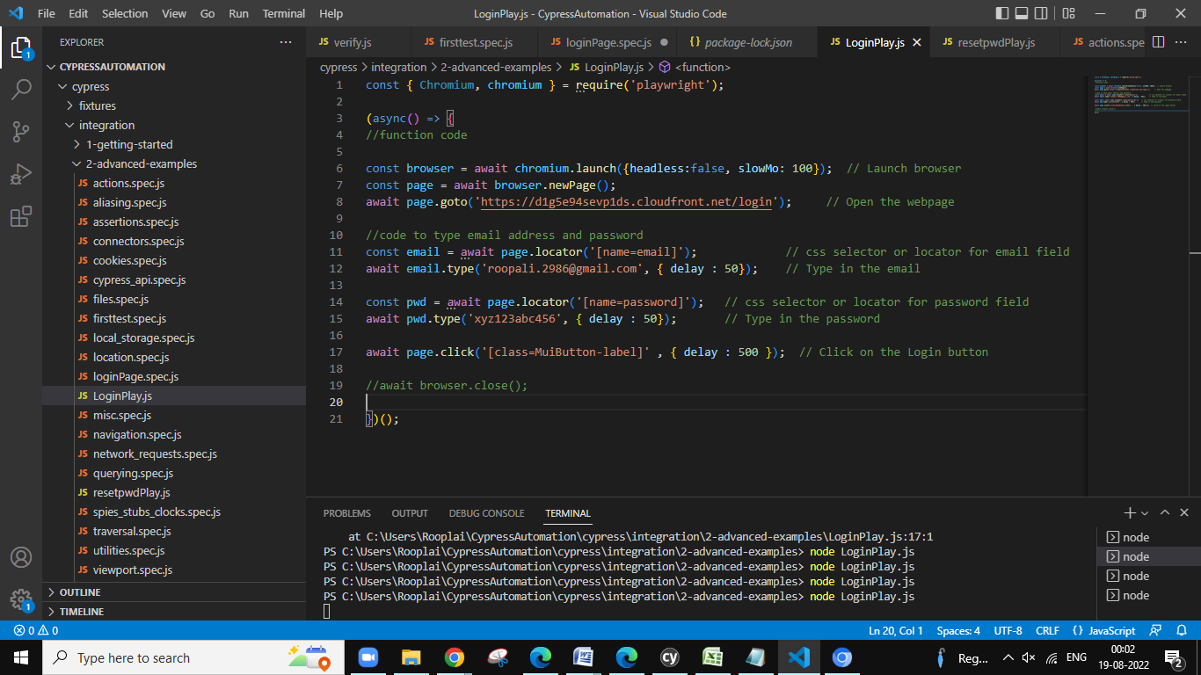

The automation worked perfectly and the message has been displayed saying “Wrong email or password.” The login credentials are incorrect, so the test case has passed.

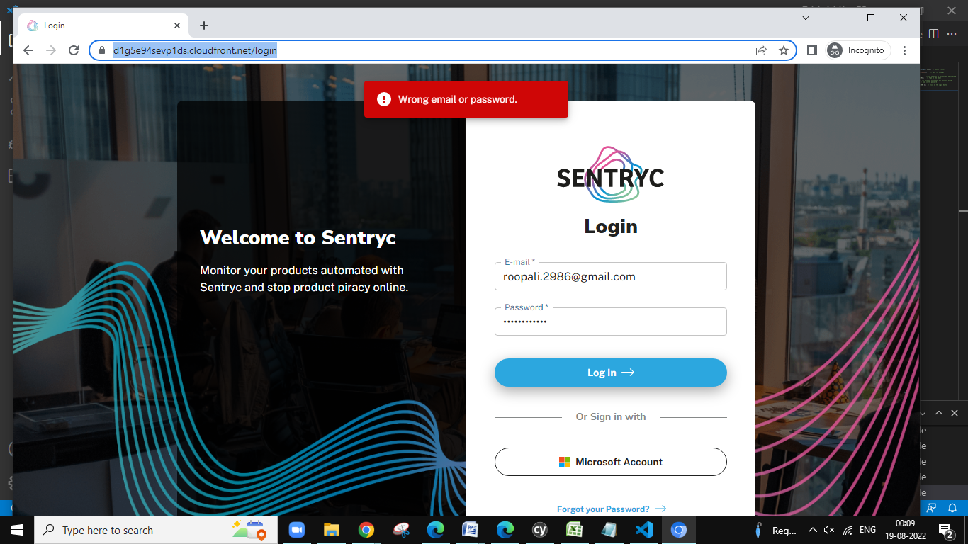

**Test Case 2 : Automate Reset Password Functionality**

Code for Reset Password verification

const { Chromium, chromium } = require('playwright');

(async() => {

//function code

const browser = await chromium.launch({headless:false, slowMo: 100}); //Launch the browser

const page = await browser.newPage();

await page.goto('https://d1g5e94sevp1ds.cloudfront.net/login');      //Open the webpage

//code to click on the Forgot your password? link

await page.locator('button', { hasText: 'Forgot your Password?'}).click();

//code to type email address

const email = await page.locator('[name=email]');

await email.type('roopali.2986@gmail.com', { delay : 50});

//Click on the Send Email button

await page.locator('button', { hasText: 'Send Email'}).click();

//Clcik on the Back to Login button to navigate back to the Login Page

await page.locator('button', { hasText: 'Back to Login'}).click();

//await browser.close();

})();

Run the script with the command – node resetpwdPlay.js

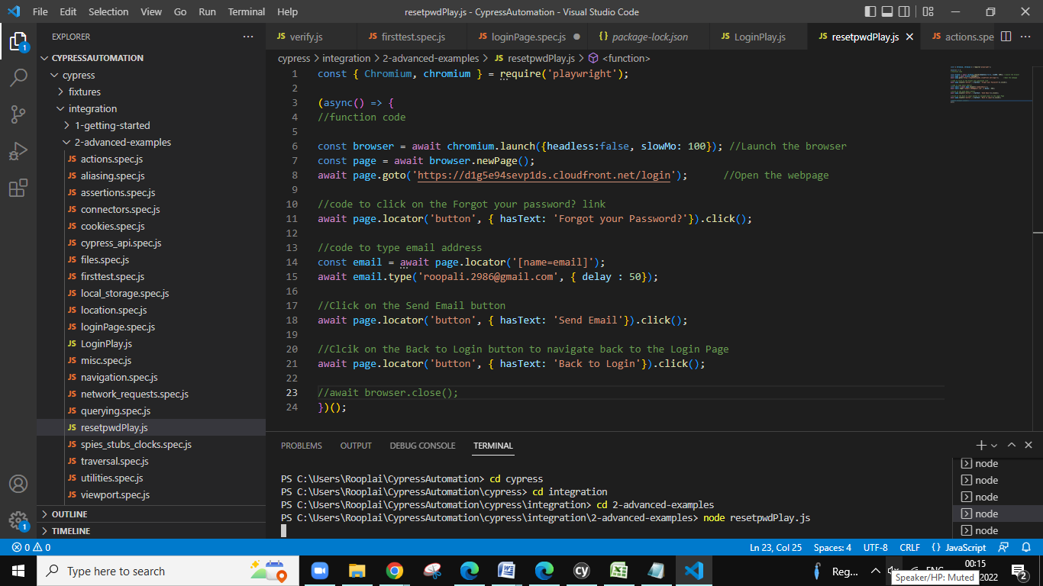

First launch the browser and open the webpage.

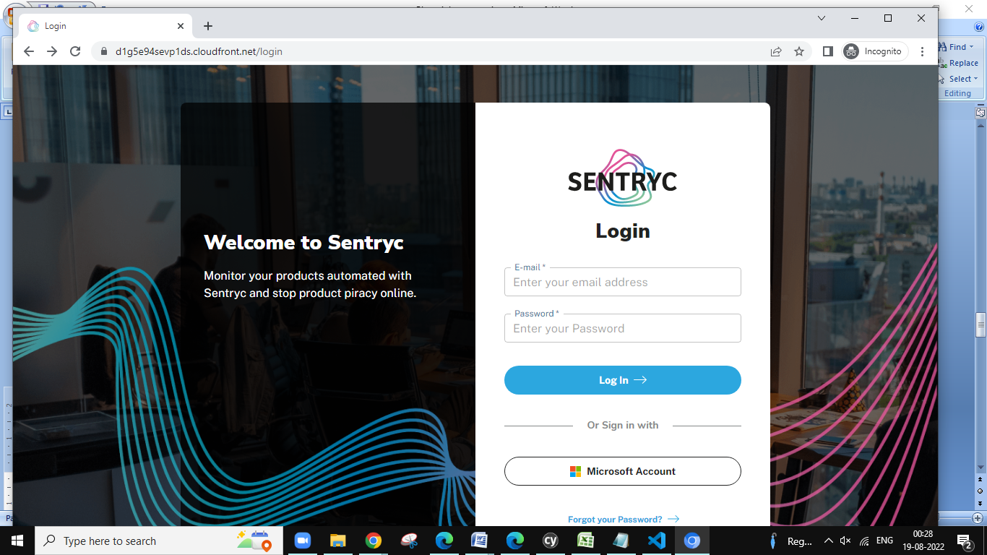

After clicking on the “Forgot your Password?” link, it navigates to the page as seen below

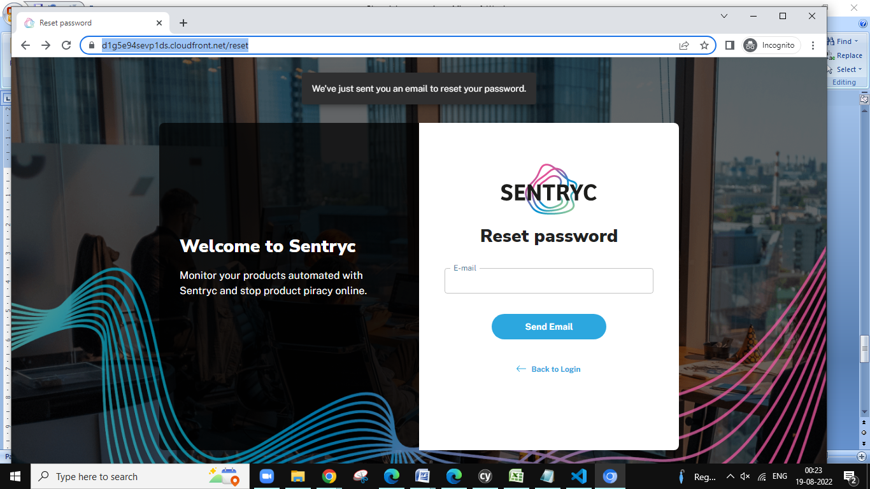

Typing the email address is automated.

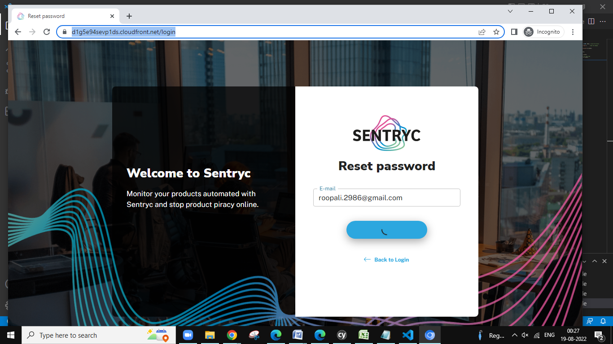

Finally we receive a message saying “We’ve just sent you an email to reset your password”

As seen in the below screenshot and also the “Back to Login” link has been clicked. Therefore it navigates back to the Login page.

